[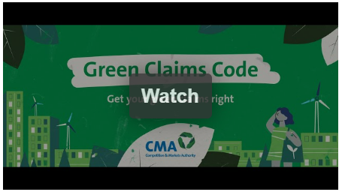

**40%**

**What is the Green Claim Code?**

The Green Claim Code has been developed by the Competition and Markets Authority and sets out **six principles**, which businesses should consider when making environmental claims to ensure they do not breach legislation.

**Watch the Competition and Markets Authority   
video to learn more about what your business  
needs to do to follow the Green Claims Code**:

**6 Principles**

Many businesses are already doing the right thing by being upfront about how green a product really is. But that’s not always the case. A recent international analysis of websites found that **40%** of green claims made online could be misleading.

**The Law requires:**

* **Any such claims must not mislead consumers and must be truthful and accurate.**
* **It is an offence to omit material information which causes a consumer to make a**

**transactional decision that they would have made otherwise**

**Now more than ever consumers are concerned about the environmental impact on the products that they buy!**

Green claims (sometimes called ‘environmental claims’ or ‘eco-friendly claims’) are claims which suggest that a product, service, or business is better for the environment. Environmental claims can be made via advertising, packaging, point of sale information and company websites. They include claims that suggest or create the impression that a product or a service:

**• has a positive environmental impact or no impact on the environment.**

**• is less damaging to the environment than a previous version of the same good or service; or**

**• is less damaging to the environment than competing goods or services.**

**Traders Guide to Making Green Claims**

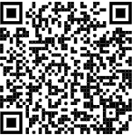

If you have questions about how these Regulations will impact your business or need further advice on regulatory matters, contact the Hertfordshire Trading Standards Business Advice Team on:

Online: [Business advice | Hertfordshire County Council](https://www.hertfordshire.gov.uk/services/business/business-advice/business-advice.aspx#DynamicJumpMenuManager_1_Anchor_1)

Or by scanning the QR Code:

1. **claims must be truthful and accurate**
2. **claims must be clear and unambiguous**
3. **claims must not omit or hide important relevant information**
4. **comparisons must be fair and meaningful**
5. **claims must consider the full life cycle of the product or service**
6. **claims must be substantiated**

**When using a Green Claim on your products you should consider:**

* **the meaning of any terms used;**
* **the qualifications and explanations of what is said;**
* **the evidence that supports those claims;**
* **the information that is not included or hidden;**
* **the colours, pictures and logos used; and**
* **the overall presentation**

**Further Legislation and Guidance:**

* [**https://greenclaims.campaign.gov.uk/#check_your_green_claims**](https://greenclaims.campaign.gov.uk/#check_your_green_claims)
* [**Consumer Protection from Unfair Trading Regulations 2008**](https://www.businesscompanion.info/en/quick-guides/good-practice/consumer-protection-from-unfair-trading) **| Business Companion**
* [**Business Protection from Misleading Marketing Claims Regulations 2008**](https://www.businesscompanion.info/en/quick-guides/good-practice/business-to-business-marketing#:~:text=The%20Business%20Protection%20from%20Misleading,rival%20products%20from%20other%20companies.) **| Business Companion**
* [**Environmental ('green') claims**](https://www.businesscompanion.info/en/quick-guides/miscellaneous/environmental-green-claims#:~:text=Environmental%20claims%20may%20be%20made,friendly%27%20or%20%27sustainable%27.) **| Business Companion**